**Instructions to begin the process for voluntary surrender or consent to suspension of a firm’s registration**

We expect a registered firm to file an application to surrender its registration when it

ceases (or intends to cease) conducting registerable activities.

When considering a firm’s voluntary surrender application, we seek to ensure that satisfactory evidence exists that:

1. all financial obligations of the person or company to his, her or its clients have been discharged;
2. all requirements, if any, prescribed by the regulations for the surrender of registration have been fulfilled or the Director is satisfied that they will be fulfilled in an appropriate manner; and
3. the surrender of the registration is not prejudicial to the public interest.

Please include the following information as part of the voluntary surrender application:

1. An **application letter** *applying* for the voluntary surrender.  * Applications filed without this letter will not be processed and returned.

There is no specific form or template for the letter.  However, please include **all** the following information in the letter:

1. a written **"consent to suspension"** of the firm’s registration in Ontario;
2. the correct categories of the firm
3. why the firm has ceased or plans to cease registerable activities
4. the date that the firm ceased registerable activities;
5. the business activities of the firm in the past (**BOTH** registerable and non-registerable activities);
6. description of what happened to the firm’s clients (e.g. accounts transferred to another registrant firm, assets liquidated, returned to clients and accounts closed, etc).
7. confirmation whether the firm holds or has ever held client assets;
8. if operating a fund, whether the fund has been liquidated and assets returned to clients, management of the fund transferred to another registrant, etc.)
9. future plan of the firm and its principals (including non-registerable activities)

This letter should be filed through our online portal, which can be accessed [here](https://www.osc.gov.on.ca/en/Dealers_forms_index.htm) (scroll down to the "Voluntary surrender" section - see screen shot below)

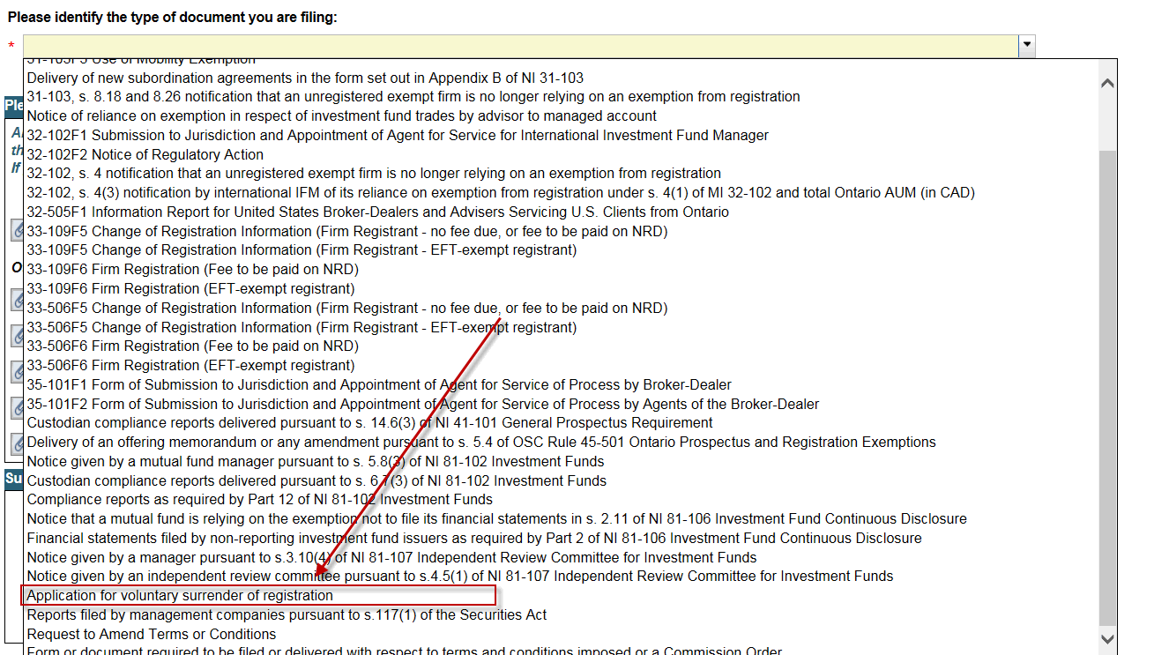

1. An **Officer's/Director's Certificate**.  A sample template is attached.
2. As part of the surrender review process, the firm may also be required to provide the following **additional information**:

* audited financial statements or unaudited interim financial information
* an auditor’s comfort letter (see sample attached) dated after registerable activities have ceased OR specified procedures report performed by a licensed public accountant/audit firm to provide evidence that all financial obligations to clients have been discharged.

**To help contribute to a successful and efficient voluntary surrender process, firms should:**

* provide all of the information described above that is required for removing one or more categories of registration.
* ensure that one of either the registrant's key principal (Chief Compliance Officer (CCO) or Ultimate Designated Person (UDP)) remains with the registrant to complete the surrender.
* ensure that any outstanding fees owing to the OSC have been paid; and
* provide additional information as requested by CRR staff.

All surrender applications are reviewed individually, and the information required in order to accept the firm’s voluntary surrender may vary on a case-by-case basis. We will not recommend that the Director approve an application to surrender registration if the information that we require is not provided to us. Further, where a firm refuses to provide the required information or is otherwise non-cooperative, this may be considered when assessing future firm and/or individual registration applications.

Officer’s Certificate

(Sample Template)

I, [Insert name of UDP], the ultimate designated person of [Insert name of firm] (the Firm) represent and provide the following information and documents to the directors of the Commissions listed below as part of the firm’s surrender of registrations:

* [Insert Commission name] (the Principal Regulator)
* [Insert Commission name]
* [Insert Commission name]
* [Insert Commission name]

(collectively, the Commissions)

1. The Firm ceased registrable activities as [Insert registration categories] on [Insert date].
2. The Firm has discharged its financial obligations to its clients, including to the [Insert as applicable - investment funds/managed accounts etc.] that it formerly managed.
3. The Firm does not hold client assets.
4. There are no existing or potential claims or liabilities against the Firm by its clients.
5. There are no unresolved complaints against the Firm by its clients.
6. The Firm’s [Insert as applicable - audited financial statements / unaudited interim financial information] submitted as part of this surrender application present fairly the financial position of the Firm in accordance with International Financial Reporting Standards or U.S. GAAP.

I represent that the above representations, evidence, information and documents are true, they are not misleading, and they do not omit any fact that is required to be stated or that is necessary to make them not misleading.

I understand that it is an offence under the *Securities Act* (Ontario) or other securities laws applicable to the Commission(s) to make a statement to the Commission(s) that is misleading or untrue.

[Insert name of UDP] Witness signature

Signed at [Insert city ], in Name

the province of [Insert province ]

on this day of [Insert date ] Address

Address

Telephone or email

**Auditor’s comfort letter**

**(see sample attached)**

[****](https://www.osc.gov.on.ca/documents/en/sample-auditor-comfort-letter-commodity-futures-act.pdf)

[****](https://www.osc.gov.on.ca/documents/en/sample-auditor-comfort-letter-ontario-securities-act.pdf)